Circles and π Interactive Introduction
Finding roughly circular or cylindrical objects and measuring their diameter and circumference with tape measures is hard to do accurately. And the constant dividing of circumference by diameter each time seems to reinforce the notion that π is a ratio, when of course it is actually irrational! So, I prefer this approach, which is based on reasoning, rather than approximate measurement.

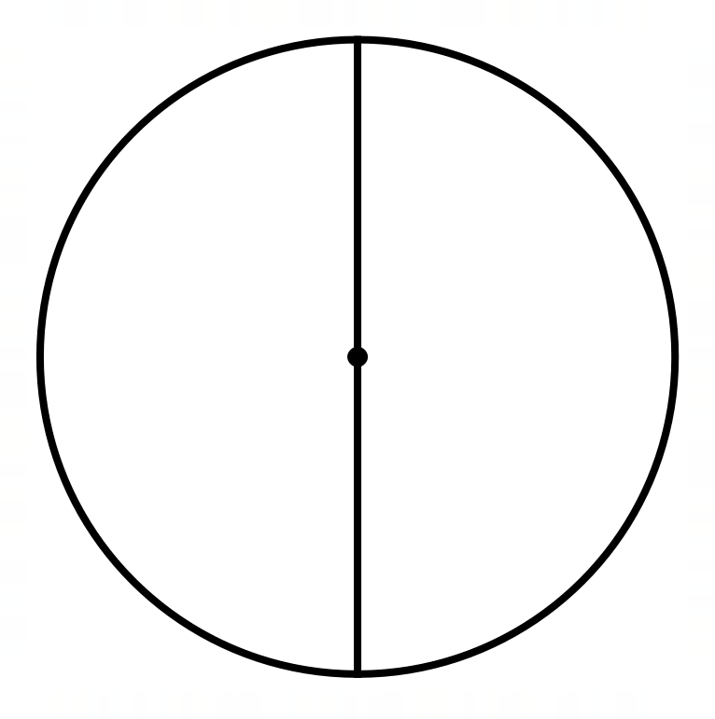
Project a circle on the board (PowerPoint file available). Make sure the projector doesn’t distort it into an oval!
T: Is it quicker to run around the circle or across the middle and back?
I would deliberately avoid ‘mathematical’ language for this initial prompt. If the weather was nice, and I had a large circle painted on the field or playground, I might consider actually doing this outside, but this would be mainly for ‘fun’ and to make the question vivid, rather than to ‘collect data’ to answer the question.
We could address ‘modelling assumptions’ here: that we are going to think about total distance rather than how easy it is to change direction, etc.
Students will realise that twice the diameter is less than the circumference, because a straight line is the shortest route from the top to the bottom and the bottom to the top. I would introduce/use the terms ‘diameter’ and ‘circumference’ from the point at which students begin answering.
T writes: $2d<c$ (in words or symbols, or both, depending on the class) to summarise what’s been said, checking that students know their $<$ from their $>$.

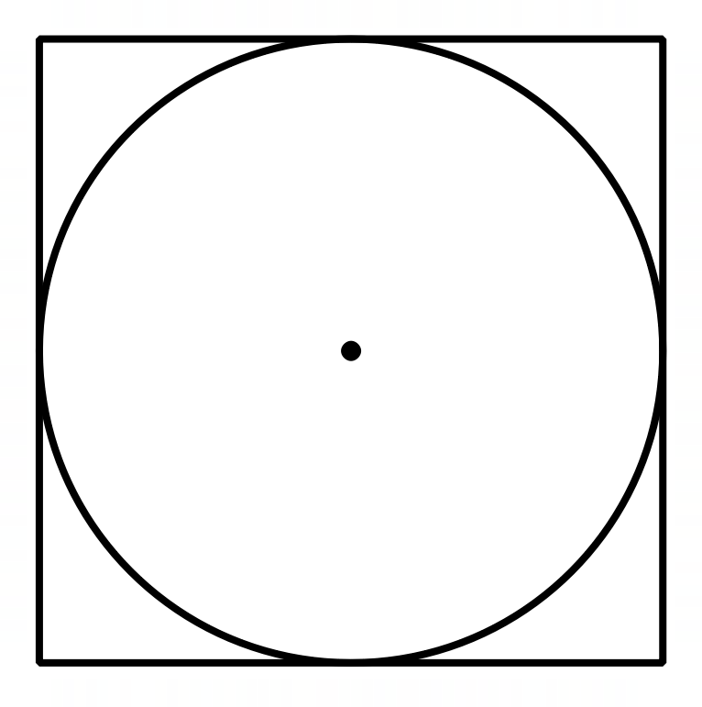
Project a circle enclosed in a square.
T: What about now? Is it shorter to run around the circle or around the square?
This will take a bit more thought, but the circle ‘cuts the corners’ of the square, so students will conclude that the circle is shorter this time.
T writes: $c<4d$ and then combines this with the previous inequality to give the double inequality $2d<c<4d$. (Have students seen double inequalities before?)
From this, it may appear ‘obvious’ that $c=3d$, but we have one more diagram to consider.
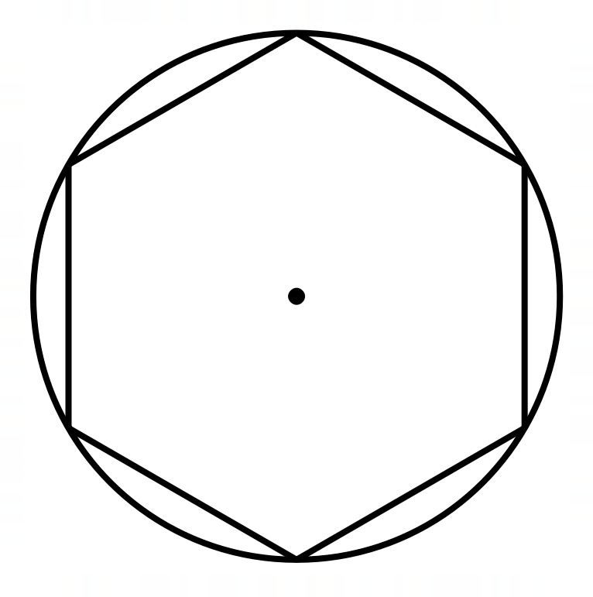
Project a circle enclosing a regular hexagon.
T: We have one more situation. Is it shorter to run around the circle or around the regular hexagon?
This time the hexagon’s sides are straight line segments which are shorter than going around the 6 circular arcs.
T: What’s the inequality now?

$$2d<3d<c<4d,$$
and the ‘$2d<$’ part of this is redundant (it was just some running to warm us up!).
T: So, the circumference is between 3 and 4 diameters long.
And from here you can explain that the number is called pi, written as π, and has a value around 3.14, but is irrational, and can’t be written as a fraction with integer numerator and denominator or as a recurring or terminating decimal. This approach at least shows that π is non-integer. To show that it is irrational (even transcendental) requires much more advanced mathematics!

Perhaps a weakness of this approach is that it just kind of assumes that $\frac{c}{d}$ should be a constant for all circles, independent of $d$, and it would perhaps be better to do some work first to establish that important idea. At some point, radius needs to be defined, but I tend to prefer $c=πd$ to $c=2πr$, at least initially. But radius is useful when deriving the area formula by chopping up the disc into a large number of sectors and rearranging these to make a parallelogram.

I wrote about the idea behind this approach in: Foster, C. (2014). Questions pupils ask: Why isn’t pi a whole number? Mathematics in School, 43(2), 37–38. https://www.foster77.co.uk/Foster,%20Mathematics%20In%20School,%20Why%20isn't%20pi%20a%20whole%20number.pdf

